

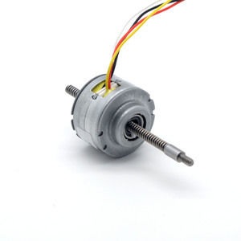

**SPECIFICATIONS:**

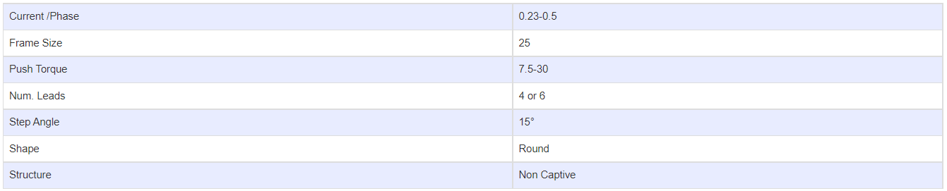

**SUBMODELS:**

*The following are common sub models for the LDO-25BYZ series. Click to request a quote and/or more information on a specific sub model.*

